Project 3 report

**Image transmission module:**

It concludes five function, each function sends an Image, from Image 1 to Image 5, also, in each function, it will send to three mobiles and give tags to each packet. Using SC_THREAD to control the interval Delta time between packets and packet duration by function wait (). And, the functions have the same free signal, when one transmits the packets, it will set network to unfree status and let others to wait for some time. The example codes are below:

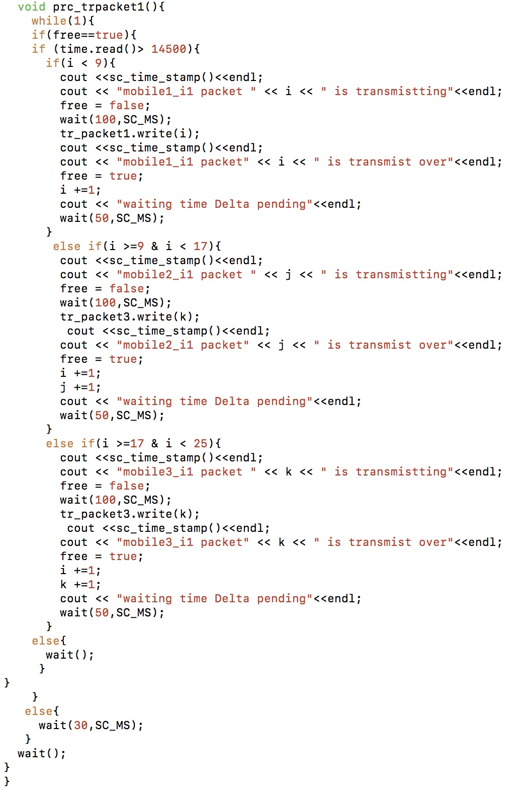

Example codes of image transmission process in network module

By changing the wait time, we can change the duration of packets and by changing the scope of i/j/k, we can change the size of packets.

**Image packet counter:**

The counter is sensitized by the change of packet tag, which is the number, and when the packets number is equal to 8 or 8000, it means the whole image has already received, then it will set control to true status and let mobiles to recognize ROIs. The example codes are below:

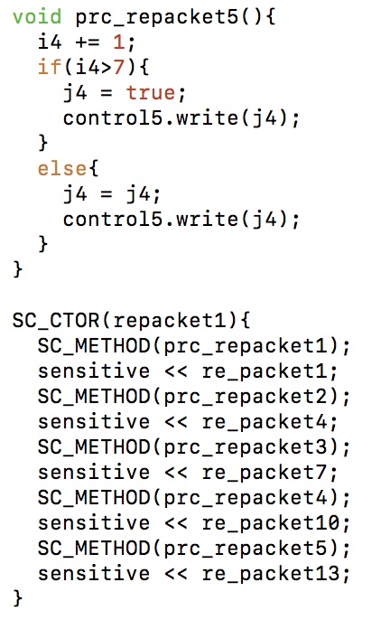

Example codes of image packet counter process in mobiles module

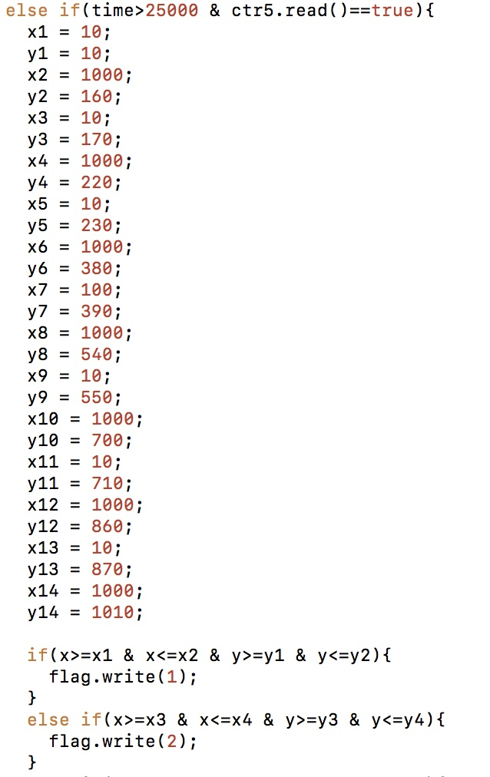

Example codes of conversion process in mobiles module

If the conversion process wants to work, it not only need the time is correct, but also need the image was already sent by server. By controlling the time of conversion process, we can move from case 1 to case 2.

**Result:**

Case1:

***Packet size****: 1Mbits*

***Bandwidth****:*

**512**Kbps (Every packet duration is 2s, transmit 8 packets for one image. Delta supposed to be 50ms and the un-free reconnected time is 30ms, supposed server to mobile transmission begin at 0s). Because the packet duration is 2s, then transmit 8 packets for one mobile need at least 16s (without collision and Delta time). Then transmit to 3 mobiles need 48s, for 5 images, need 240s. So, with the collision and Delta time, some mobile can’t get the whole data before displaying time and can’t display the image (Figure 1).

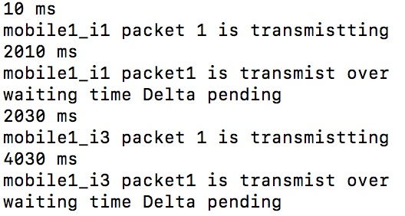

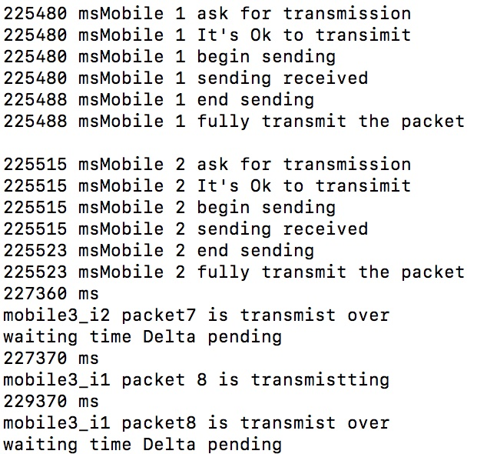

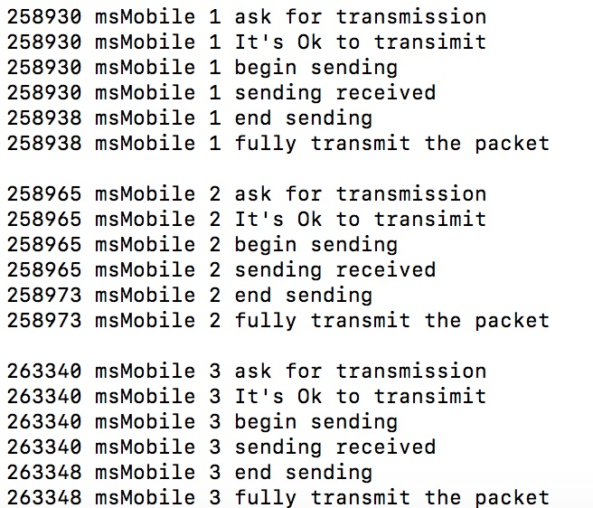

Figure 1: Result 1

**1**Mbps (Every packet duration is 1s, transmit 8 packets for one image. Delta supposed to be 50ms and the un-free reconnected time is 30ms, supposed server to mobile transmission begin at 71s), Figure 2.

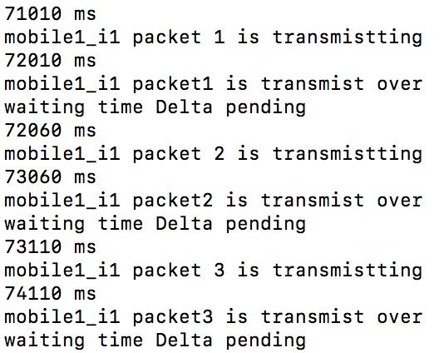

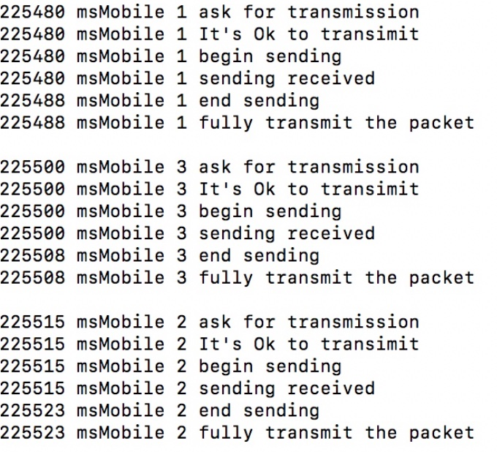

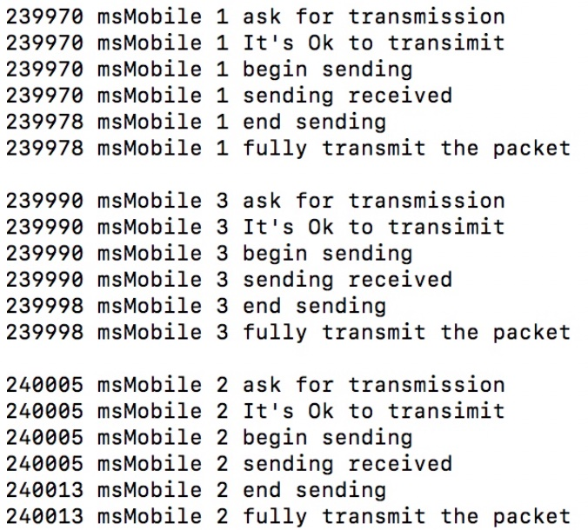

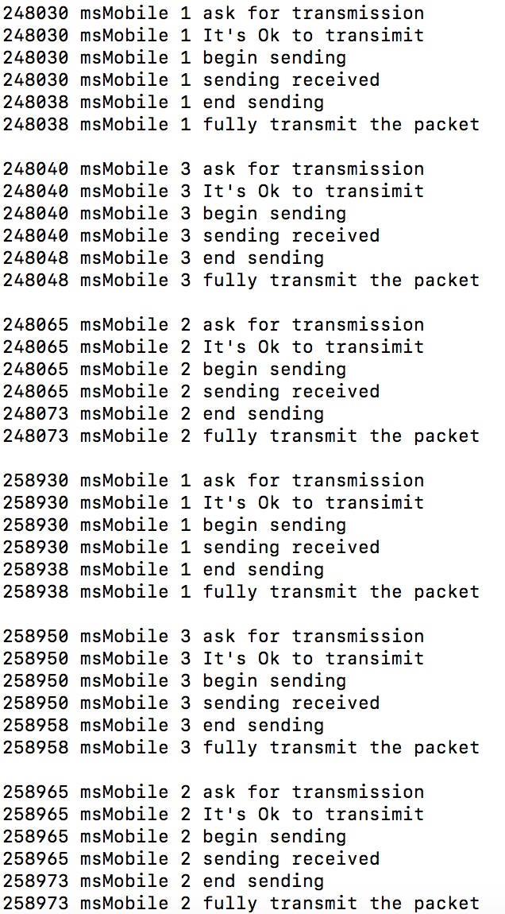

Figure 2: Result 2

We can see that there are 4 packets of ROI received, which means in 270s simulation time, about more than 80 tuples are collected and transmit to server.

**5**Mbps (Every packet duration is 0.2s, transmit 8 packets for one image. Delta supposed to be 50ms and the un-free reconnected time is 30ms, supposed server to mobile transmission begin at 175s), the server also receives 4 packets of ROI from mobiles, but in Figure 3 and the Figures in the future, I just show a part of result to save the space.

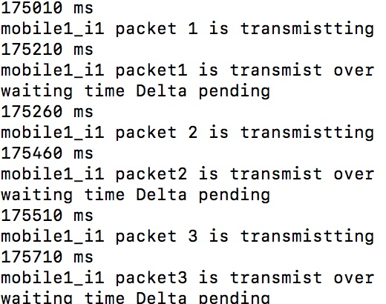

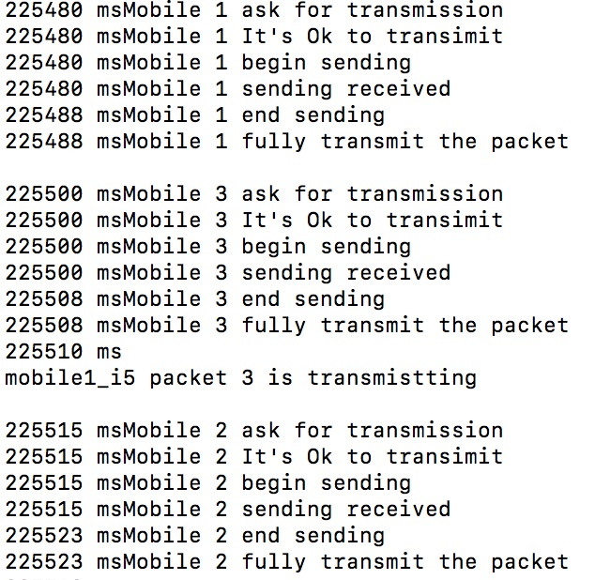

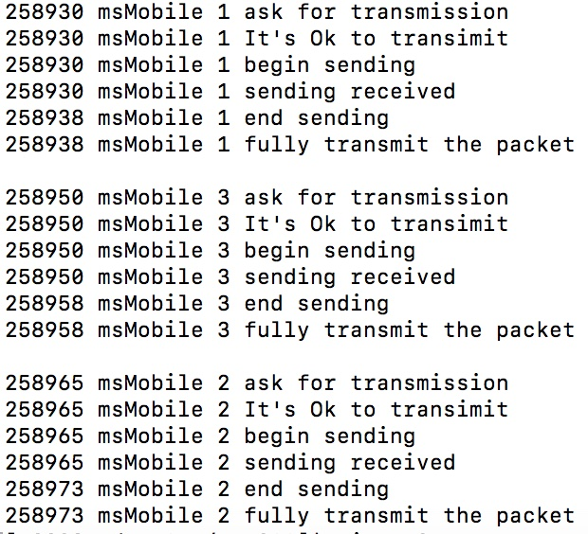

Figure 3: Result 3

**10**Mbps (Every packet duration is 0.1s, transmit 8 packets for one image. Delta supposed to be 50ms and the un-free reconnected time is 30ms, supposed server to mobile transmission begin at 195s), Figure4.

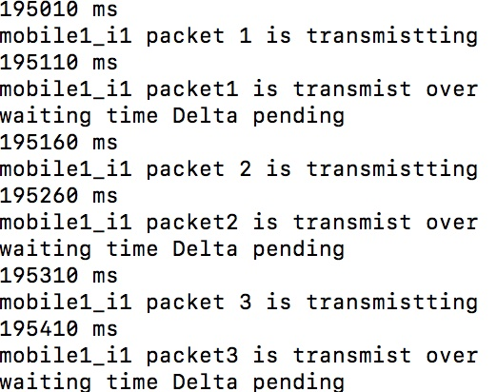

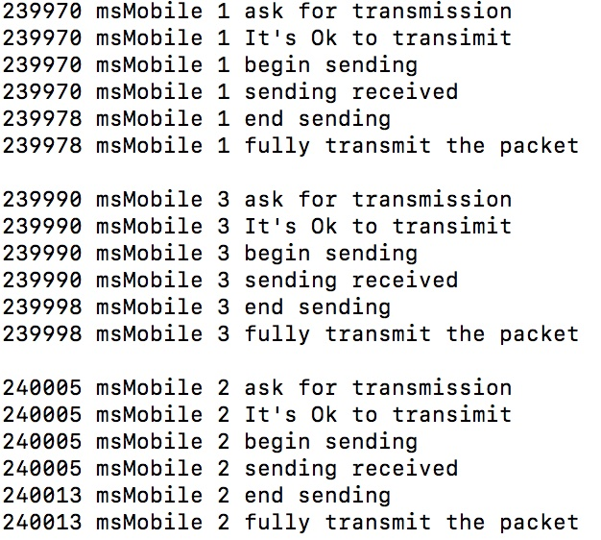

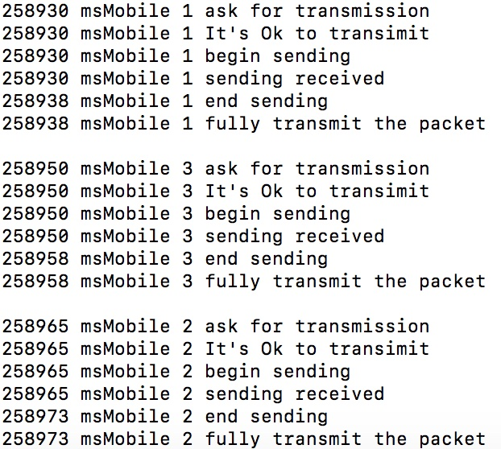

Figure 4: Result 4

***Packet size****: 1kbits*

***Bandwidth****:*

**512**Kbps (Every packet duration is 2ms, transmit 8000 packets for one image. Delta supposed to be 10us and the un-free reconnected time is 30us, supposed server to mobile transmission begin at 0s). Because the total duration of transmission won’t change, as a result, the time point that server transmit to mobile will not change. Like $2ms× 8000 × 3 × 5 =240s$, is same in packet size is 1Mbits. The clock of transmission from server to mobile in server should change into SC_US to get the result. Figure 5.

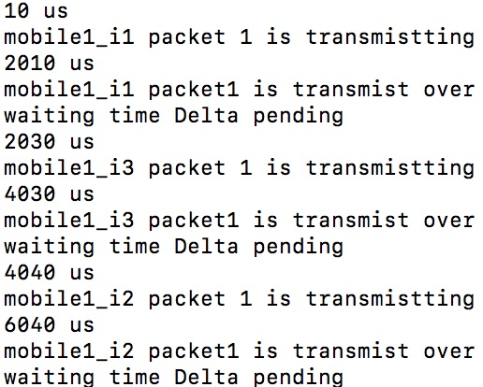

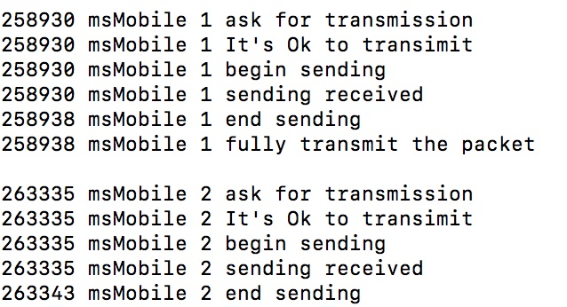

Figure 5: Result 5

**1**Mbps (Every packet duration is 1ms, transmit 8000 packets for one image. Delta supposed to be 10us and the un-free reconnected time is 30us, supposed server to mobile transmission begin at 71s). Figure 6.

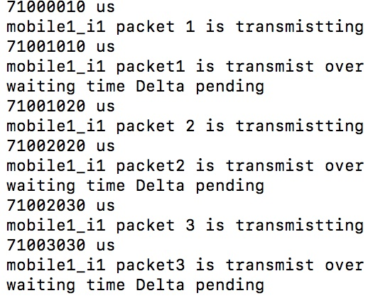

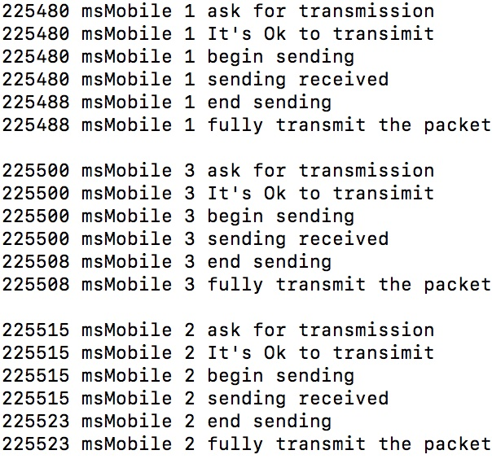

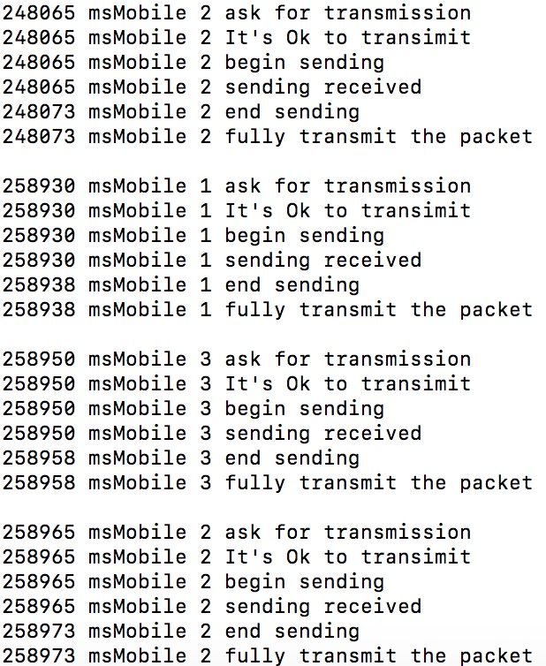

Figure 6: Result 6

**5**Mbps (Every packet duration is 200us, transmit 8000 packets for one image. Delta supposed to be 10us and the un-free reconnected time is 30us, supposed server to mobile transmission begin at 175s). Figure 7.

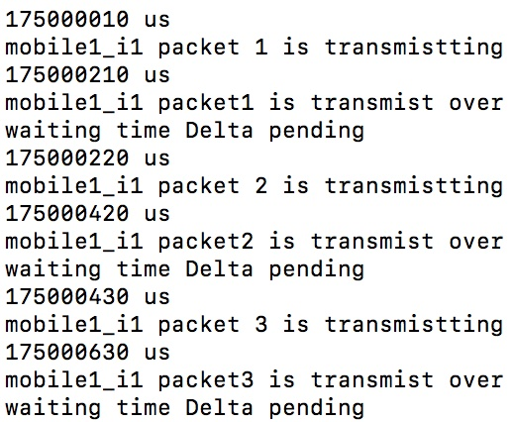

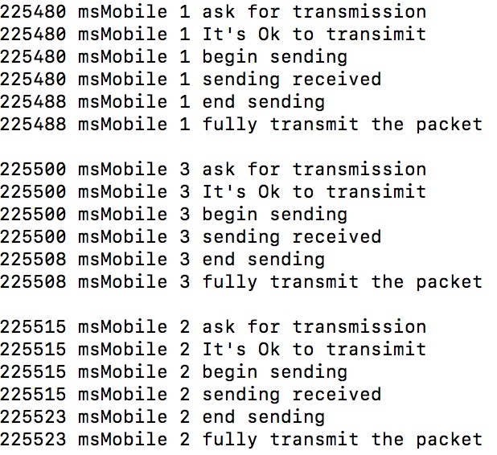

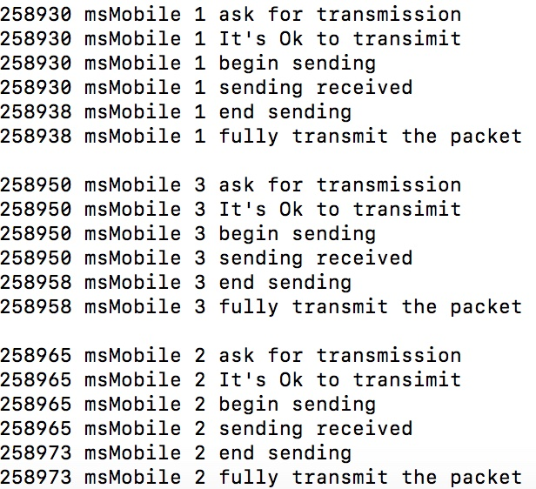

Figure 7: Result 7

**10**Mbps (Every packet duration is 100us, transmit 8000 packets for one image. Delta supposed to be 10us and the un-free reconnected time is 30us, supposed server to mobile transmission begin at 195s). Figure 8.

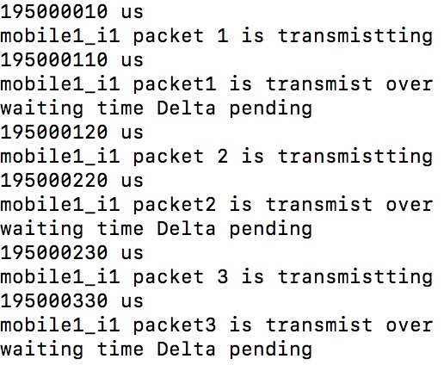

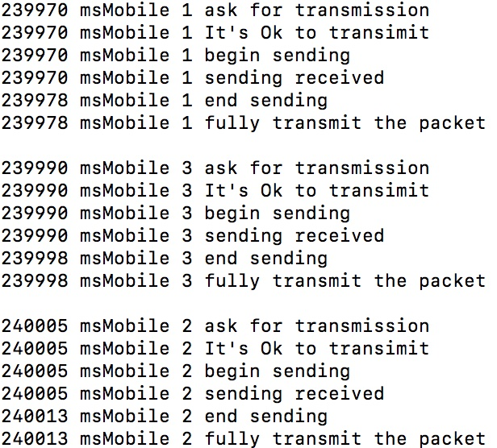

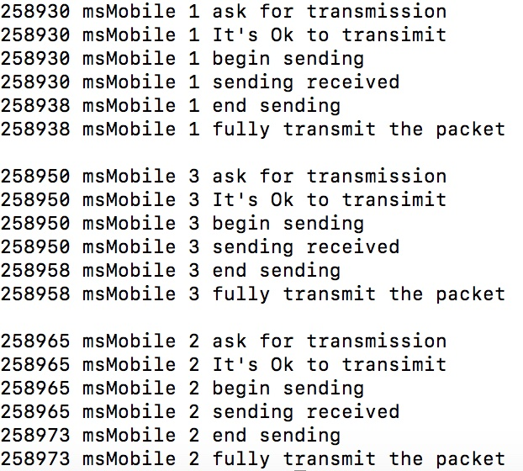

Figure 8: Result 8

Case2:

***Packet size****: 1Mbits*

***Bandwidth***

**512**Kbps (Every packet duration is 2s, transmit 8 packets for one image. Delta supposed to be 50ms and the un-free reconnected time is 30ms, supposed server to mobile transmission begin at 0s). Figure 9.

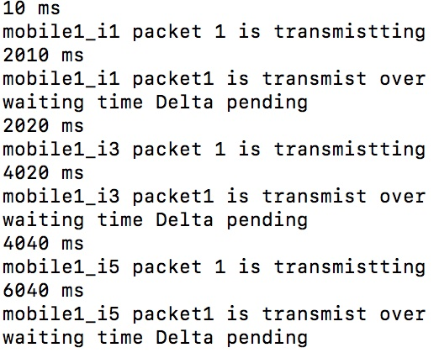

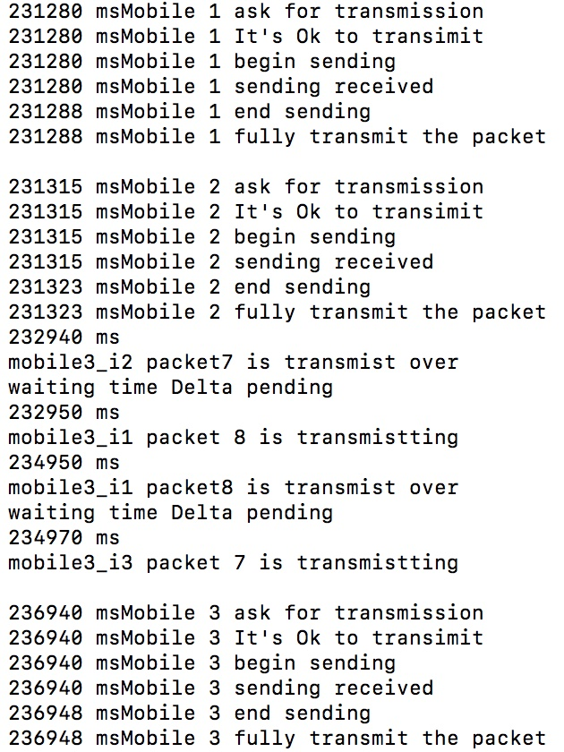

Figure 9: Result 9

**1**Mbps (Every packet duration is 1s, transmit 8 packets for one image. Delta supposed to be 50ms and the un-free reconnected time is 30ms, supposed server to mobile transmission begin at 71s), Figure 10.

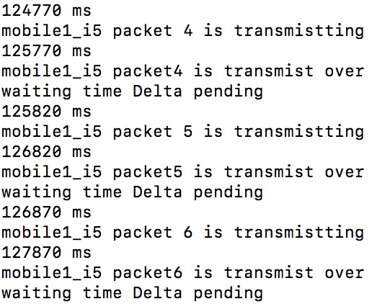

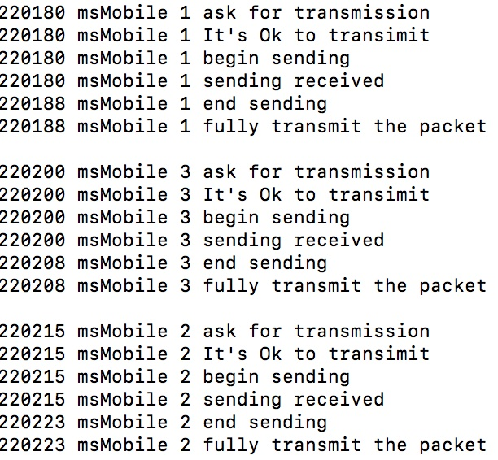

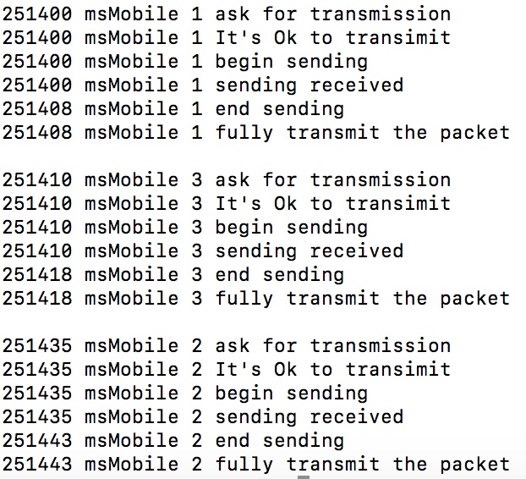

Figure 10: Result 10

**5**Mbps (Every packet duration is 0.2s, transmit 8 packets for one image. Delta supposed to be 50ms and the un-free reconnected time is 30ms, supposed server to mobile transmission begin at 125s) Figure11.

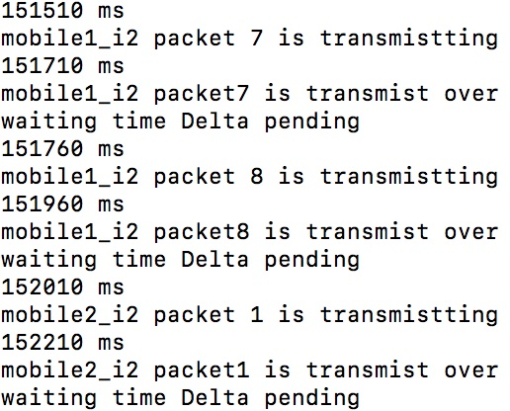

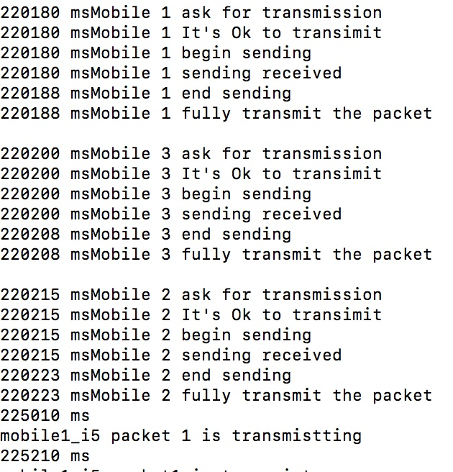

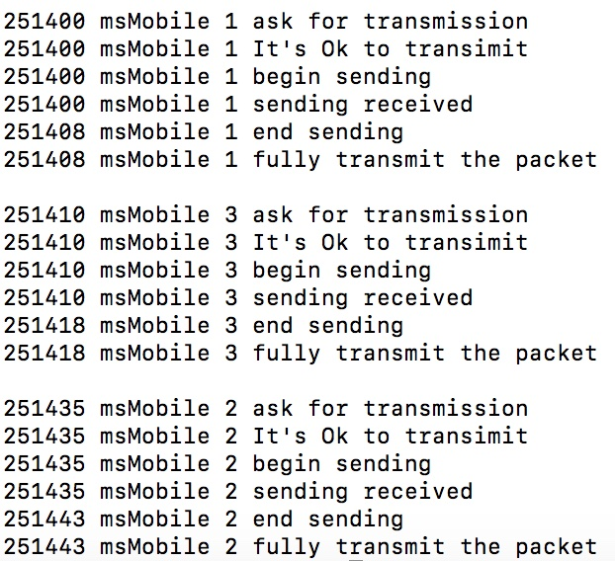

Figure 11: Result 11

**10**Mbps (Every packet duration is 0.1s, transmit 8 packets for one image. Delta supposed to be 50ms and the un-free reconnected time is 30ms, supposed server to mobile transmission begin at 145s), Figure12.

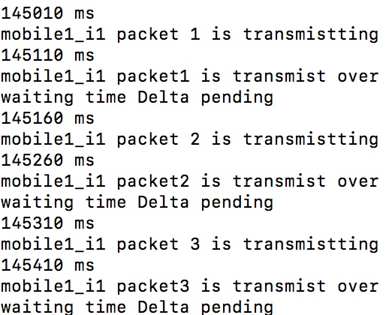

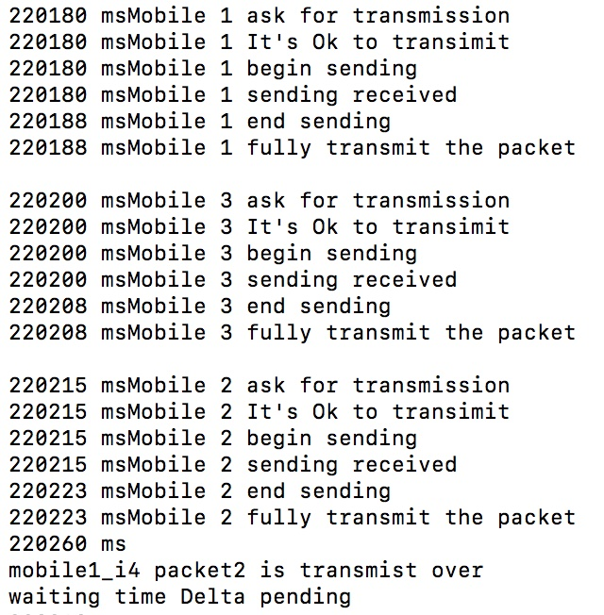

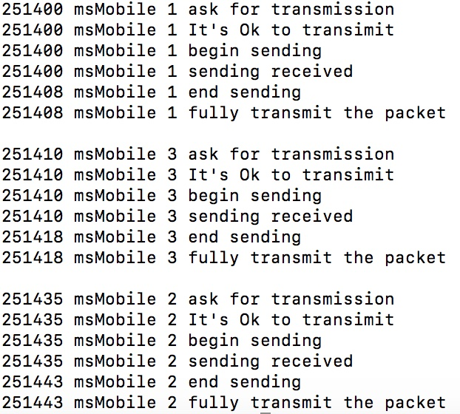

Figure 12: Result 12

***Packet size****: 1kbits*

***Bandwidth***

**512**Kbps (Every packet duration is 2ms, transmit 8000 packets for one image. Delta supposed to be 10us and the un-free reconnected time is 30us, supposed server to mobile transmission begin at 0s). Figure 13.

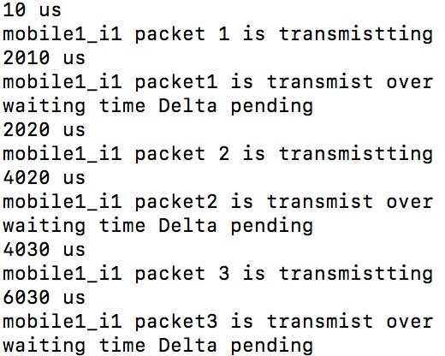

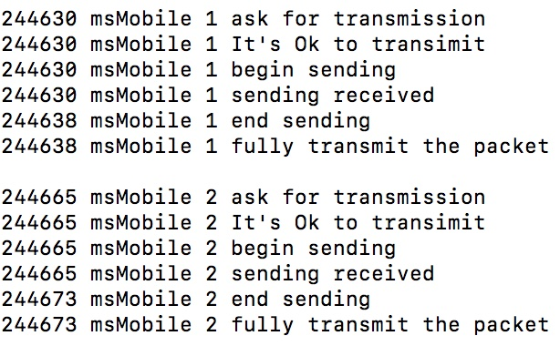

Figure 13: Result 13

**1**Mbps (Every packet duration is 1ms, transmit 8000 packets for one image. Delta supposed to be 10us and the un-free reconnected time is 30us, supposed server to mobile transmission begin at 21s). Figure 14.

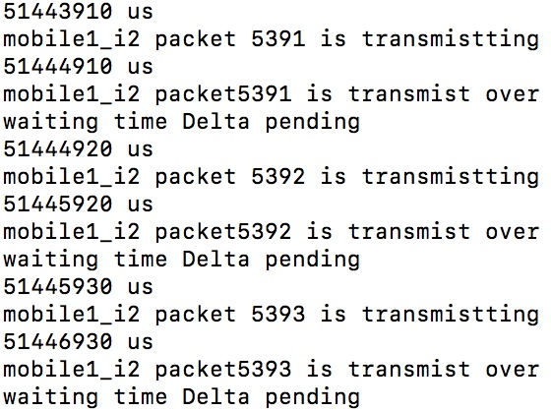

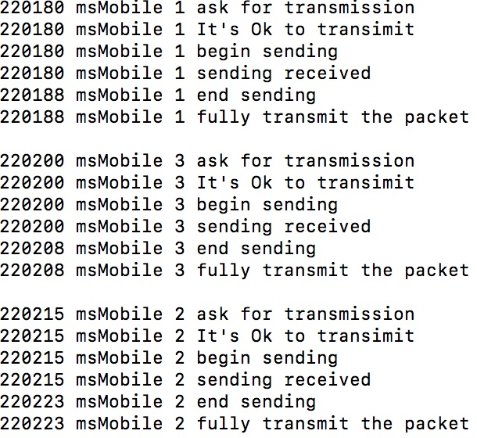

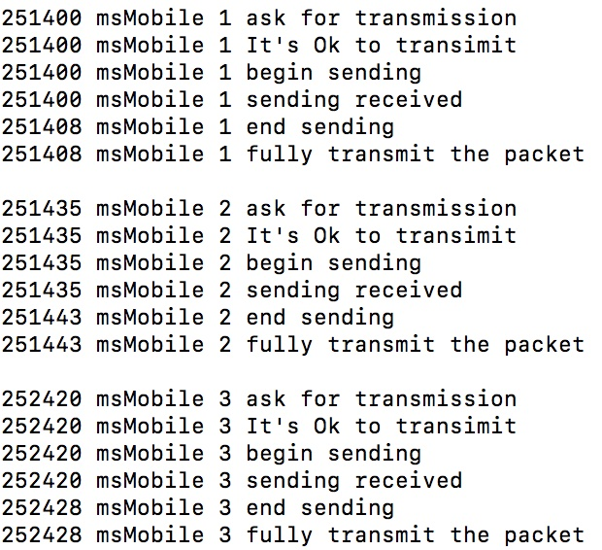

Figure 14: Result 14

**5**Mbps (Every packet duration is 200us, transmit 8000 packets for one image. Delta supposed to be 10us and the un-free reconnected time is 30us, supposed server to mobile transmission begin at 125s). Figure 15.

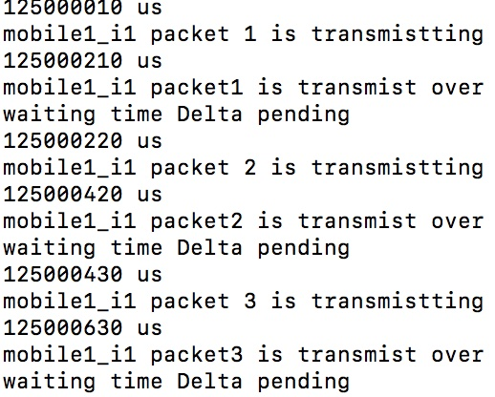

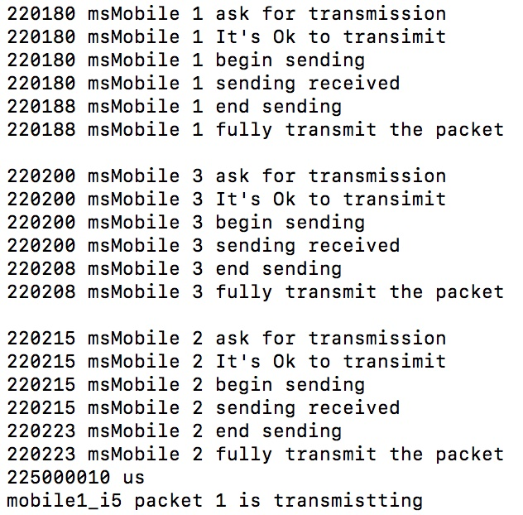

Figure 15: Result 15

**10**Mbps (Every packet duration is 100us, transmit 8000 packets for one image. Delta supposed to be 10us and the un-free reconnected time is 30us, supposed server to mobile transmission begin at 145s). Figure 12.

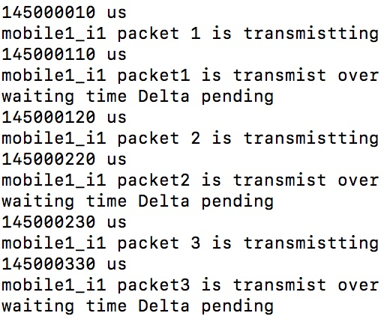

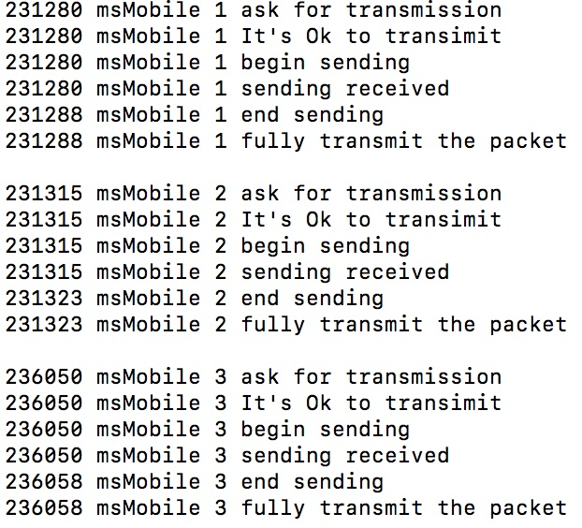

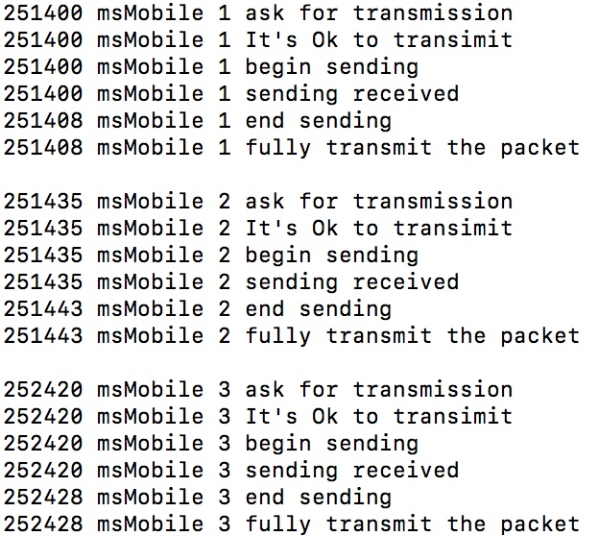

Figure 16: Result 16